# 

# 

# **Assessment**

# **Route 53 and DNS**

Trainee Name : Aditya Upadhyay

Newers ID : 3978

Mentor Name : Tarun Saxena

College : UPES

1) create a private hosted zone named "[ttn-internal.com](http://ttn-internal.com/)" attached to the default vpc. and created a cname record "[myloadbalance.ttn-internal.com](http://myloadbalance.ttn-internal.com/)" for any load balancer pointed to its dns. Do reverse lookup for the record from any instance of the vpc and share the result.

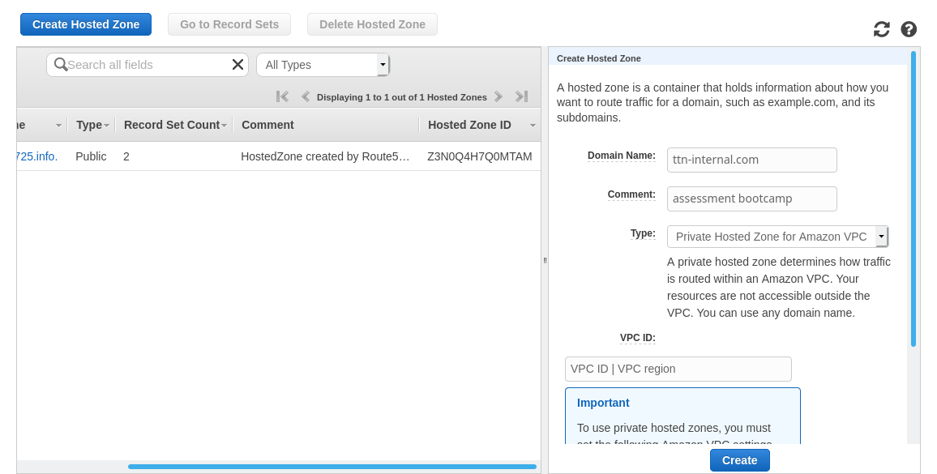

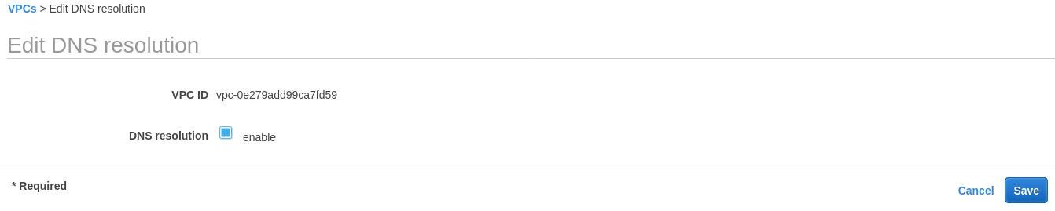

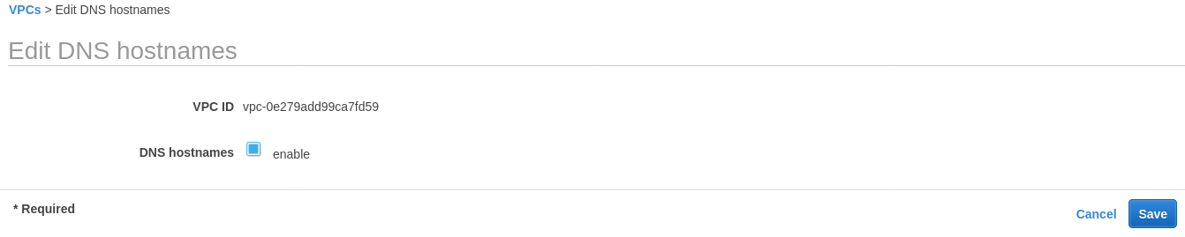

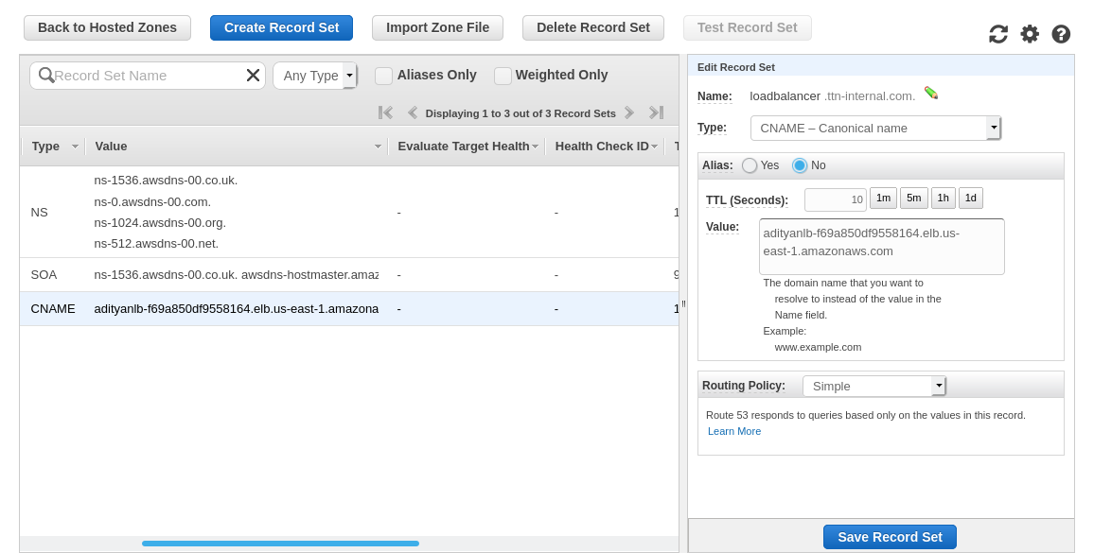

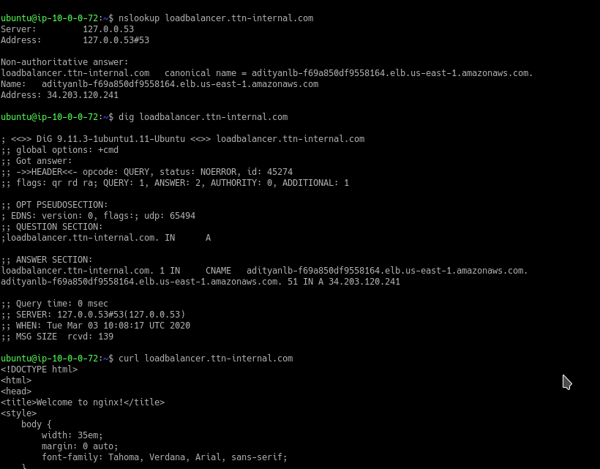

2) Create a non-public S3 bucket and give appropriate permissions to a server to download objects from bucket but not to put or delete anything in it.

